INTEGRATE ZSCALER WITH IDENTITY PROVIDERS (IDPS) SUCH AS AZURE AD, OKTA, AND ACTIVE DIRECTORY FOR SEAMLESS AUTHENTICATION AND AUTHORIZATION.

Title: Integrate Zscaler with Identity Providers (IdPs) such as Microsoft Azure Active Directory, Okta, and Active Directory for seamless authentication and authorization.
This project outlines the strategy and implementation plan for integrating the Zscaler cloud security platform with enterprise Identity Providers (IdPs). The primary goal of this integration is to create a secure and centralized authentication framework that allows users to access internet and internal applications through a single trusted identity.
Traditional network security architectures often relied on VPN-based access where users were granted broad network access after authentication. This approach increased security risks because once users entered the network, they could potentially access multiple systems. To address these challenges, modern organizations are adopting Zero Trust security models, where access is granted based on verified identity and contextual policies rather than network location.
By integrating Zscaler with identity platforms such as Azure AD, Okta, and Active Directory, organizations can create a single source of truth for identity management. This ensures that authentication decisions are centralized and security policies such as Multi-Factor Authentication (MFA), device compliance, and role-based access control are consistently enforced.
Through the use of modern authentication protocols such as SAML (Security Assertion Markup Language), OIDC (OpenID Connect), and SCIM (System for Cross-domain Identity Management), the integration enables seamless Single Sign-On (SSO) and automated user provisioning.
Ultimately, this project establishes a secure identity-driven access model that improves user experience while strengthening organizational security posture.

Abstract
This project focuses on integrating the Zscaler cloud security platform with leading Identity Providers including Microsoft Azure Active Directory, Okta, and on-premises Active Directory. The objective of this integration is to create a unified identity framework that enables secure authentication and centralized authorization for users accessing internet and internal applications.
By delegating authentication to trusted identity providers, the organization eliminates the need for maintaining separate credentials within Zscaler. Users authenticate using their corporate identities, and Zscaler enforces access policies based on identity, device posture, and contextual factors.
The integration relies on widely adopted identity protocols such as SAML for Single Sign-On, OIDC for modern authentication workflows, and SCIM for automated user provisioning and lifecycle management. These technologies enable secure communication between the identity provider and the Zscaler platform.
One of the key advantages of this approach is improved security through Multi-Factor Authentication (MFA) and conditional access policies enforced at the identity provider level. At the same time, automated user provisioning ensures that user accounts and group memberships remain synchronized between the identity platform and Zscaler.
By combining identity governance with cloud security enforcement, this integration supports the principles of Zero Trust Architecture, ensuring that every access request is authenticated, authorized, and continuously verified.

Use Case Scenarios
Use Case Scenario 1: Remote Faculty Access to Research Data
A research professor working from an off-campus location requires secure access to sensitive research files stored on an internal server. Instead of connecting through a full VPN tunnel, Zscaler Private Access grants application-level access only to the required research server.
Output
- User identity verified: Research_Faculty_Group
- Context-aware access enforced: Access allowed from external locations
- Connection restricted: Research File Server only
- Security enforcement: Multi-Factor Authentication required
- No lateral movement across other internal systems

Use Case Scenario 2: Student Access to Library Resources
A graduate student needs access to subscription-based academic journals hosted on the university network. Using Zscaler integration with Azure AD, the student authenticates through SSO and receives access only to the library portal.
Output
- User identity verified: Enrolled_Student_Group
- Access scope limited to library portal and databases
- Policy enforcement prevents unauthorized access
- Seamless user experience without VPN connection
- No access to administrative systems

Use Case Scenario 3: HR Administrator Access to Payroll System
An HR administrator needs access to the payroll system for salary processing.
Due to the sensitive nature of payroll data, access must follow strict security controls.
Output
- User identity verified: HR_Payroll_Group
- Access allowed only during business hours
- Step-up authentication through MFA
- Access restricted to payroll application server
- Complete audit trail maintained

Use Case Scenario 4: IT Helpdesk Remote Troubleshooting
An IT support engineer must remotely troubleshoot a server issue from home.
Zscaler enables Just-in-Time (JIT) access, granting temporary privileges for the specific task.
Output
- User identity verified: IT_Helpdesk_Group
- Temporary administrative access granted
- Access limited to a specific target server
- Privilege boundaries enforced
- Real-time session monitoring enabled

Use Case Scenario 5: Contractor Access to Project Management Tool
An external contractor working on a specific project needs access to the project management application.
Access should automatically expire after the contract ends.
Output
- User identity verified: External_Contractor_Group
- Time-limited access enforced
- Connection restricted to project management application
- Automatic deprovisioning after contract expiration
- Segmentation prevents access to internal financial or HR systems

Stage-1
Title of the Project
Integrate Zscaler with Identity Providers (IdPs) such as Azure AD, Okta, and Active Directory for seamless authentication and authorization.
Overview
The integration of Zscaler with enterprise Identity Providers such as Microsoft Azure Active Directory represents a modern approach to secure authentication and access management in cloud-based environments. Traditional security architectures relied heavily on perimeter-based defences and Virtual Private Networks (VPNs), where users were granted broad network access after authentication. While this model worked in earlier network environments, it introduced several security risks including excessive permissions, lack of granular access control, and the possibility of lateral movement across internal systems once a user gained entry.
This project focuses on implementing a secure identity-centric access model by integrating Zscaler with Identity Providers like Azure AD. In this architecture, the identity provider becomes the primary authority responsible for verifying user identities, while Zscaler acts as the enforcement point that controls and monitors access to applications and internet resources. By leveraging modern authentication protocols such as SAML (Security Assertion Markup Language), OIDC (OpenID Connect), and SCIM (System for Cross-domain Identity Management), the integration ensures seamless Single Sign-On (SSO) and automated user provisioning across the platform.
Through this integration, organizations can centralize authentication processes and eliminate the need for managing separate user accounts across multiple security systems. Users authenticate through the identity provider, and Zscaler enforces access policies based on user roles, group memberships, device posture, and contextual information such as location and risk level. This identity-driven model supports the principles of Zero Trust Architecture, where every access request is continuously verified rather than automatically trusted.
Another significant advantage of this integration is improved operational efficiency for administrators. Automated user provisioning and deprovisioning through SCIM ensures that user lifecycle changes—such as onboarding, role modification, or offboarding—are automatically synchronized between the identity provider and Zscaler. This reduces administrative overhead, minimizes human errors, and enhances overall security posture.
Ultimately, integrating Zscaler with identity providers creates a unified and secure access framework where identity becomes the central control point for security decisions. This approach not only strengthens organizational cybersecurity but also improves user experience by providing seamless access to applications and services from any location while maintaining strict security policies.

LIST OF TEAMMATES:
S.NO | NAME | COLLEGE | MAIL ID
1 | Vinumithra A | AVP College of Arts and Science | Vinumithra74@gmail.com
2 | Subhaga S K | AVP College of Arts and Science | Subhaga63@gmail.com
3 | Sandhiya M | AVP College of Arts and Science | Sandhiyamanoharan1705@gmail.com
4 | Shahin S | AVP College of Arts and Science | Shahinshanawas12@gmail.com
5 | Shirin Banu | AVP College of Arts and Science | Shirinbanu547@gmail.com

LIST OF VULNERABILITY TABLE
S.no | Vulnerability Name | CWE/CVE - No
1 | Absolute Path Traversal | CWE-36: Absolute Path Traversal
2 | External Control of System or Configuration Setting | CWE-15: External Control of System or Configuration Setting
3 | Vulnerable and Outdated Components (Dependency Vulnerability) | CWE-1104: Use of Unmaintained Third-Party Components
4 | Key Management Errors | CWE-320 – Key Management Errors
5 | Command Injection | CWE-77: Improper Neutralization of Special Elements used in a Command
6 | Incorrect User Management / Improper User Role Assignment | CWE-286 – Incorrect User Management
7 | Improper Certificate Validation | CWE-295 – Improper Certificate Validation
8 | Uncontrolled Search Path Element | Uncontrolled Search Path Element
9 | Information Loss or Omission | Information Loss or Omission
10 | Uncaught Exception | CWE-248 – Uncaught Exception

REPORT:
1.Vulnerability Name:
Absolute Path Traversal
CWE/CVE:
CWE-36: Absolute Path Traversal
OWASP/SANS Category:
OWASP Top 10 – Broken Access Control
Description:
Absolute Path Traversal is a vulnerability that occurs when an application uses external user input to construct file paths without properly validating or sanitizing the input. Attackers can exploit this weakness by supplying absolute path sequences such as /etc/passwd or /abs/path, allowing them to access files and directories outside the intended restricted directory. This vulnerability enables unauthorized navigation of the file system, potentially exposing sensitive data or system resources that should not be accessible to the user.
Business Impact:
If this vulnerability is exploited, attackers may gain unauthorized access to confidential files, system configuration files, or application data stored on the server. This could lead to data leakage, system compromise, or modification of critical files, affecting the confidentiality, integrity, and availability of the organization’s systems. In severe cases, attackers may overwrite important files, bypass authentication mechanisms, or execute malicious code, resulting in service disruption, reputational damage, and potential financial loss for the organization.
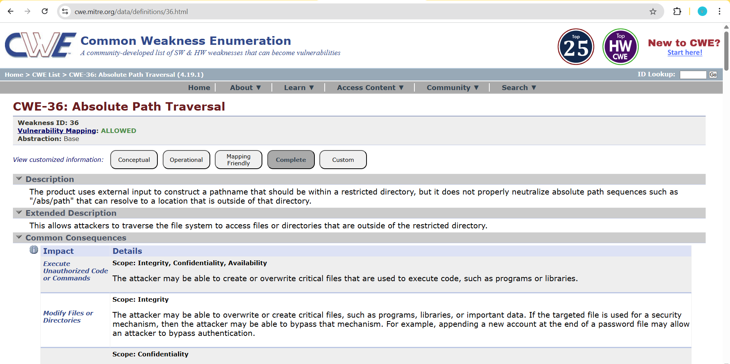

2. Vulnerability name:
External Control of System or Configuration Setting
CWE/CVE:
CWE-15: External Control of System or Configuration Setting
OWASP/SANS Category:
OWASP Top 10 – Security Misconfiguration
Description:
External Control of System or Configuration Setting is a vulnerability that occurs when an application allows external users or untrusted inputs to control system configuration settings. Normally, configuration settings determine how an application behaves, including security rules, file locations, authentication mechanisms, and system permissions. These settings are expected to be controlled only by trusted administrators or internal system processes.
However, when an application exposes configuration parameters to external input without proper validation or access control, attackers can manipulate these settings. By altering configuration values, attackers may force the system to behave in unexpected or malicious ways. For example, an attacker may change file paths, disable security features, modify environment variables, or redirect the system to load malicious resources.
This vulnerability typically occurs when developers allow configuration data to be read directly from user-controlled sources such as URL parameters, cookies, HTTP headers, environment variables, or external configuration files without verifying their integrity. As a result, attackers can influence how the application runs and potentially bypass important security mechanisms.
External Control of System or Configuration Setting is dangerous because configuration settings often control critical application behaviour, including logging mechanisms, authentication services, access permissions, and system resource management. If attackers gain the ability to manipulate these settings, they may be able to disrupt application functionality, bypass security controls, or gain unauthorized access to sensitive system components.
Business Impact:
If this vulnerability is exploited, attackers may manipulate system configurations to disrupt services, weaken security protections, or gain unauthorized system access. This can lead to application malfunction, data leakage, and unauthorized modification of system settings. In severe cases, attackers may disable security controls, redirect application behaviour, or execute malicious code through manipulated configurations. Such incidents can result in operational downtime, loss of sensitive data, reputational damage, and financial loss for the organization.
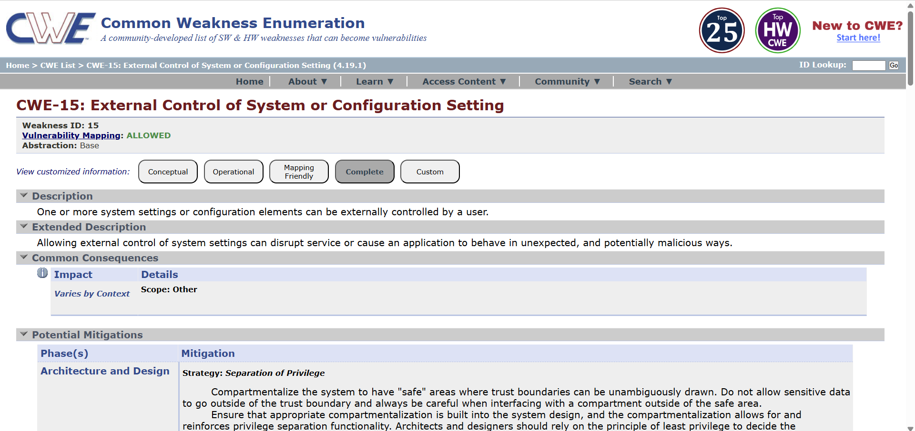

3.Vulnerability Name:
Vulnerable and Outdated Components (Dependency Vulnerability)
CWE/CVE:
CWE-1104: Use of Unmaintained Third-Party Components
OWASP/SANS Category:
OWASP Top 10 – A06: Vulnerable and Outdated Components
Description:
Vulnerable and Outdated Components is a security weakness that occurs when an application uses third-party libraries, frameworks, or software components that contain known vulnerabilities or are no longer maintained. Modern software applications heavily depend on external components such as open-source libraries, plugins, APIs, and frameworks to speed up development and provide additional functionality. However, if these components are outdated or contain known security flaws, they may introduce vulnerabilities into the application.
Attackers often scan applications to identify the versions of libraries or dependencies being used. If a known vulnerability exists in that component, attackers can exploit it to gain unauthorized access, execute malicious code, or disrupt system operations. Since these components are integrated directly into the application, any vulnerability present in them can affect the overall security of the system.
Tools like OWASP Dependency-Track help organizations analyze software components and detect vulnerabilities in dependencies using Software Bill of Materials (SBOM). By monitoring these dependencies, developers can identify outdated libraries and update them before attackers exploit them.
This vulnerability is particularly dangerous because many organizations are unaware of all the external components included in their applications. If components are not regularly monitored and updated, they can remain vulnerable for long periods and become easy targets for attackers.
Business Impact:
If vulnerable or outdated components are used in an application, attackers may exploit known security flaws to gain unauthorized access, execute malicious code, or compromise sensitive data. This can lead to data breaches, system downtime, service disruption, and loss of customer trust. Additionally, organizations may face financial losses, legal penalties, and reputational damage if exploited vulnerabilities result in the exposure of confidential information or disruption of business operations.

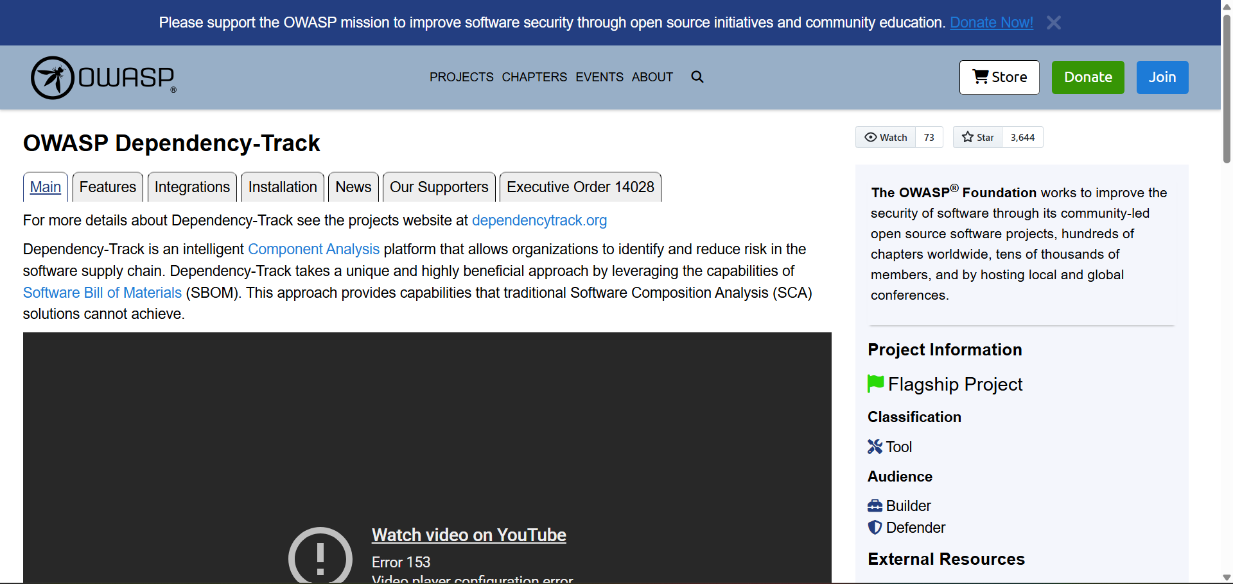

4.Vulnerability Name:
Key Management Errors
CWE/CVE:
CWE-320 – Key Management Errors
OWASP / SANS Category:
- OWASP Top 10: A02:2021 – Cryptographic Failures
- SANS Top 25: Use of Hard-coded Credentials / Improper Key Management
Description:
Key Management Errors occur when cryptographic keys are not securely generated, stored, distributed, rotated, or revoked within an application or system. Weak key management practices such as using hard-coded keys, reusing keys, failing to rotate keys regularly, or storing keys in insecure locations can compromise the effectiveness of cryptographic protections. If attackers gain access to these keys, they may be able to decrypt sensitive information, impersonate systems, or bypass security mechanisms.

Business Impact:
Improper key management can lead to the exposure of sensitive information such as passwords, financial records, and personal data if attackers obtain cryptographic keys. Compromised keys can allow attackers to decrypt confidential communications, forge authentication tokens, or impersonate trusted systems. This may result in data breaches, regulatory penalties, financial losses, and severe reputational damage to the organization.
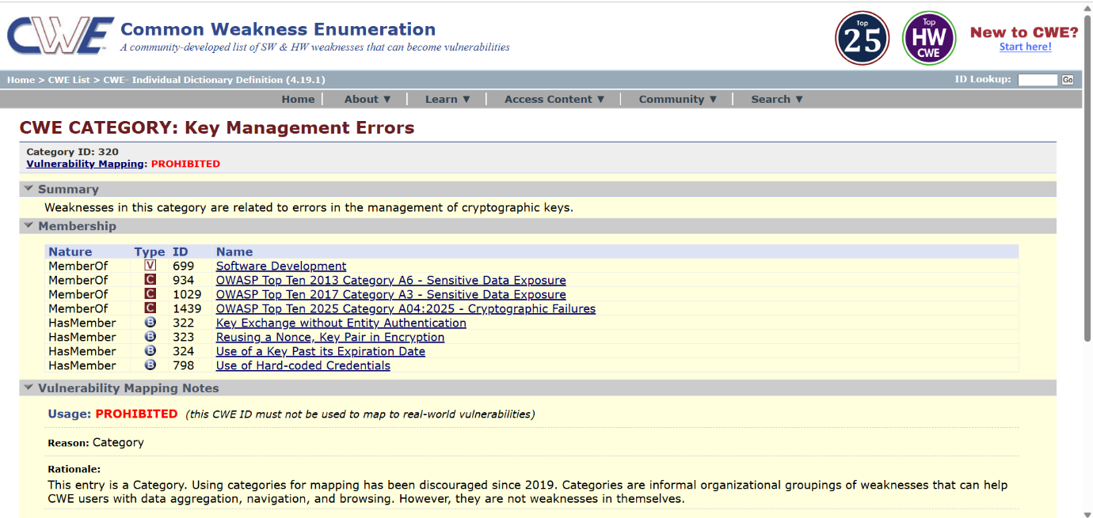
5.Vulnerability Name:
Command Injection
CWE/CVE:
CWE-77: Improper Neutralization of Special Elements used in a Command
OWASP/SANS Category:
OWASP Top 10 – A03: Injection
Description:
Command Injection occurs when an application constructs system commands using user-supplied input without properly validating or sanitizing the input. Attackers can insert malicious commands or special characters that are interpreted by the operating system.
When this happens, the attacker can manipulate the command execution process and run unauthorized commands on the server. This vulnerability usually appears in applications that use functions to execute system-level commands such as shell scripts, operating system commands, or external programs.
For example, if an application executes a system command like ping or ls using user input without validation, an attacker may append additional commands (such as; rm -rf /) which the system will execute.
Business Impact:
Command Injection is considered a critical vulnerability because it can lead to severe consequences:
- Unauthorized execution of system commands
- Full system compromise by attackers
- Data theft or modification
- Server takeover or remote control
- Service disruption or denial of service
- Exposure of sensitive system information
These impacts can damage the organization’s reputation and may lead to financial and legal consequences.

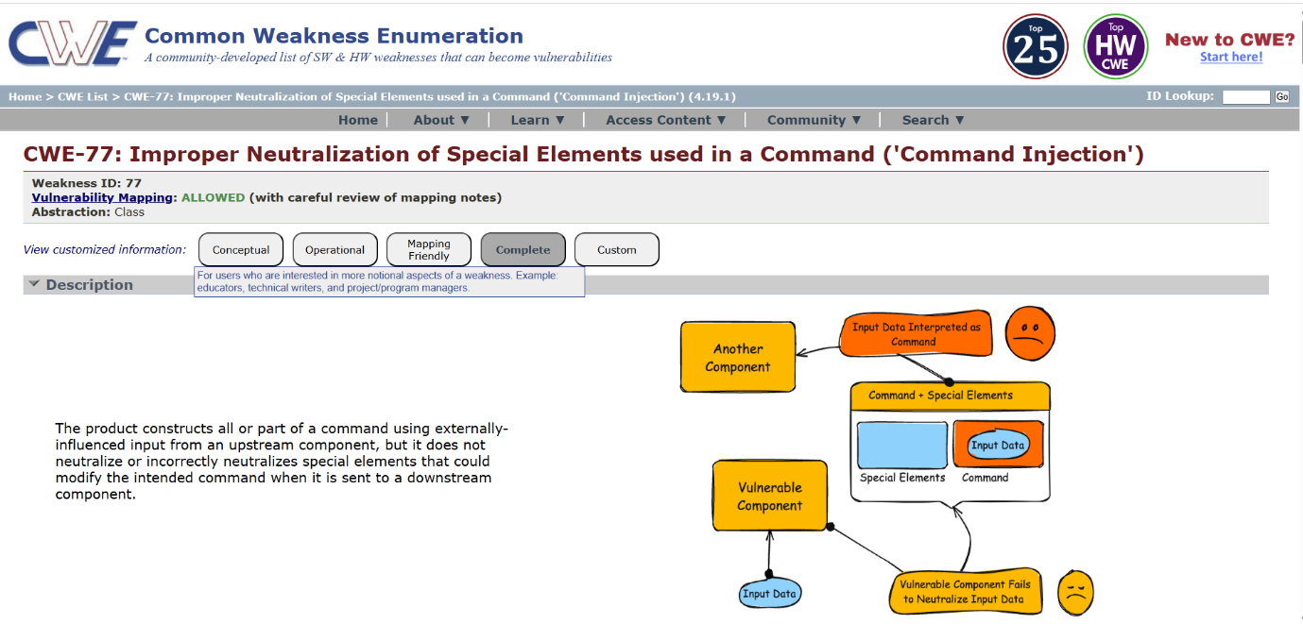

6.Vulnerability Name:
Incorrect User Management / Improper User Role Assignment
CWE/CVE:
CWE-286 – Incorrect User Management
OWASP / SANS Category:
- OWASP Top 10: Broken Access Control (A01:2021)
- SANS Top 25: Improper Access Control
Description:
Incorrect User Management occurs when an application fails to properly manage users, roles, or permission assignments. This can happen when users are placed in incorrect groups, given excessive privileges, or when role validation is not properly enforced. As a result, users may gain unauthorized access to sensitive resources, functions, or data within the system.
Business Impact:
If incorrect user management exists in an application, users may be assigned to inappropriate roles or permission groups, allowing them to access sensitive information or perform actions beyond their authorized privileges. This can lead to unauthorized disclosure, modification, or deletion of critical data. Attackers or malicious insiders may exploit this weakness to escalate privileges, gain administrative access, or bypass security controls. As a result, the organization may face financial losses, legal and regulatory penalties, operational disruption, and reputational damage due to compromised data confidentiality, integrity, and availability.
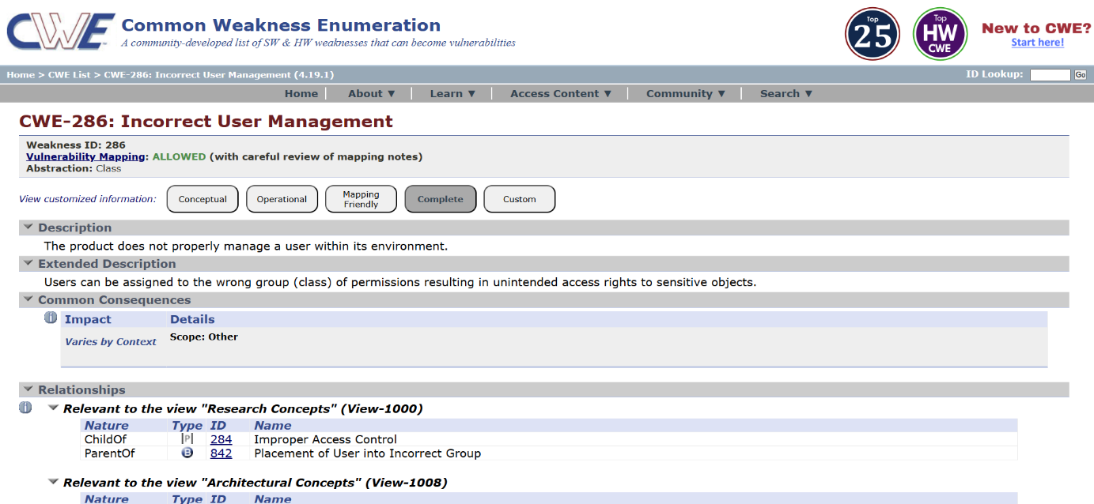
7.Vulnerability Name:
Improper Certificate Validation
CWE/CVE:
CWE-295 – Improper Certificate Validation
OWASP / SANS Category:
- OWASP Top 10: A02:2021 – Cryptographic Failures
- SANS Top 25: Improper Certificate Validation / Improper Authentication
Description:
Improper Certificate Validation occurs when an application fails to properly verify the authenticity and validity of SSL/TLS certificates during secure communications. This can happen if the application does not check the certificate authority (CA), hostname, expiration date, or trust chain correctly. As a result, the application may accept invalid, self-signed, or malicious certificates, allowing attackers to intercept or manipulate encrypted communications.
Business Impact:
If certificate validation is not properly implemented, attackers may perform Man-in-the-Middle (MitM) attacks to intercept, monitor, or modify sensitive communications between users and servers. This can lead to the exposure of confidential data such as login credentials, financial information, or personal records. Compromised communication channels can result in data breaches, loss of customer trust, regulatory penalties, and financial or reputational damage to the organization.

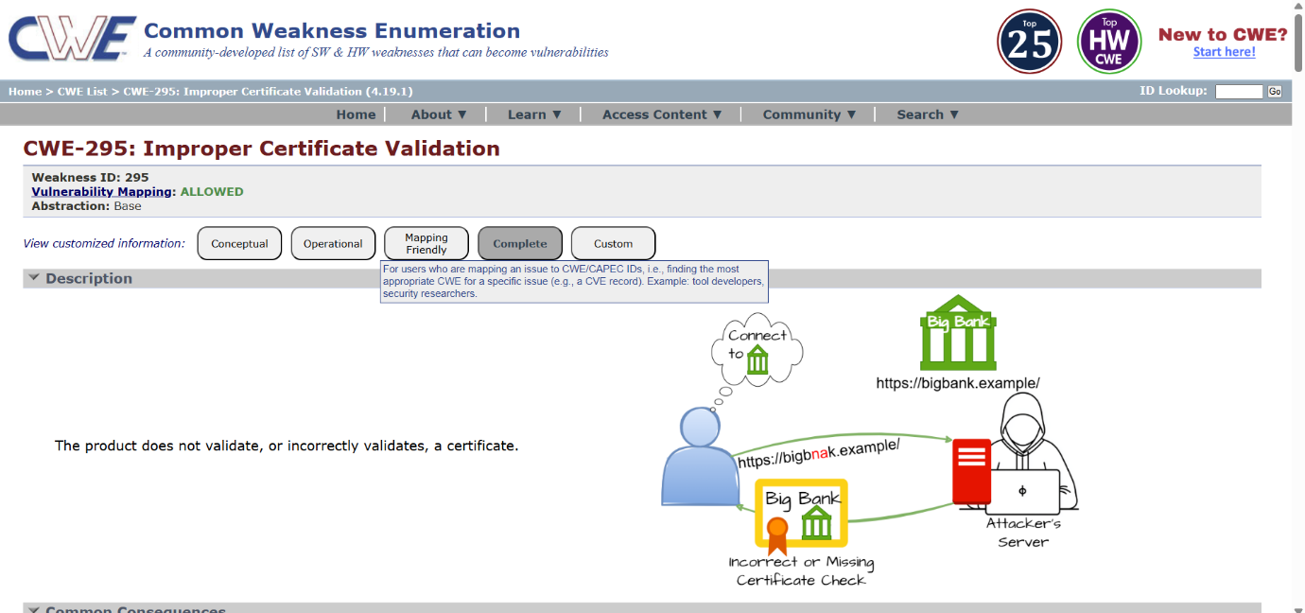
8.Vulnerability Name:
Uncontrolled Search Path Element
CWE/CVE:
CWE-427 – Uncontrolled Search Path Element
OWASP / SANS Category:
- OWASP Top 10: A05:2021 – Security Misconfiguration
- SANS Top 25: Uncontrolled Search Path Element
Description:
Uncontrolled Search Path Element occurs when an application relies on a search path to locate executables, libraries, or resources, but one or more directories in that path can be modified or controlled by untrusted users. If the application loads resources without specifying a fully qualified path, attackers may place malicious files in these directories. As a result, the application may load and execute the attacker’s malicious code instead of the legitimate resource.
Business Impact:
If this vulnerability is exploited, attackers may execute malicious code within the application’s environment by placing crafted files or libraries in directories that are searched by the system. This can lead to unauthorized code execution, system compromise, data theft, or privilege escalation. Such attacks may disrupt business operations, compromise sensitive systems, and cause financial losses and reputational damage to the organization.

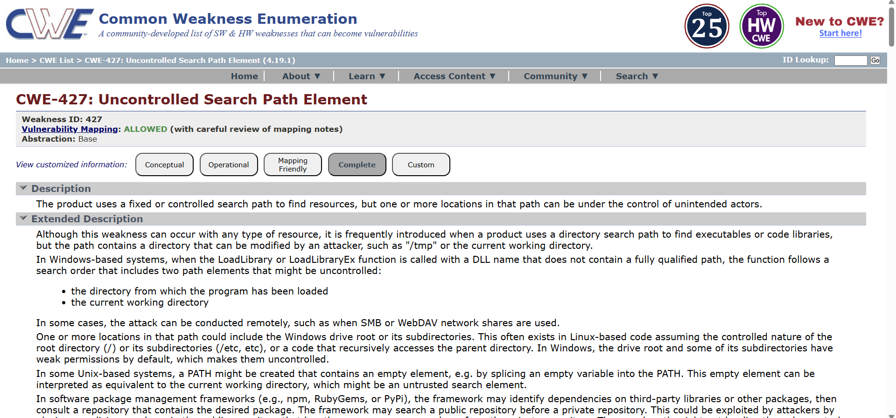
9.Vulnerability Name:
Information Loss or Omission
CWE/CVE:
CWE-221 – Information Loss or Omission
OWASP / SANS Category:
- OWASP Top 10: A09:2021 – Security Logging and Monitoring Failures
- SANS Top 25: Improper Handling of Security-Relevant Information
Description:
Information Loss or Omission occurs when a system fails to record, logs incorrectly, or omits important security-relevant information during operations. This may include incomplete logging of authentication events, missing audit trails, or improper recording of errors and security activities. As a result, security teams may not have sufficient information to detect suspicious activities, investigate incidents, or make accurate security decisions.
Business Impact:
If security-relevant information is not properly recorded or is omitted from logs, organizations may be unable to detect unauthorized activities, investigate security incidents, or perform effective forensic analysis. This lack of visibility can allow attackers to remain undetected within the system for extended periods. Additionally, incomplete audit trails can lead to compliance violations, operational risks, and reputational damage, as organizations may fail to demonstrate accountability and traceability during security investigations.

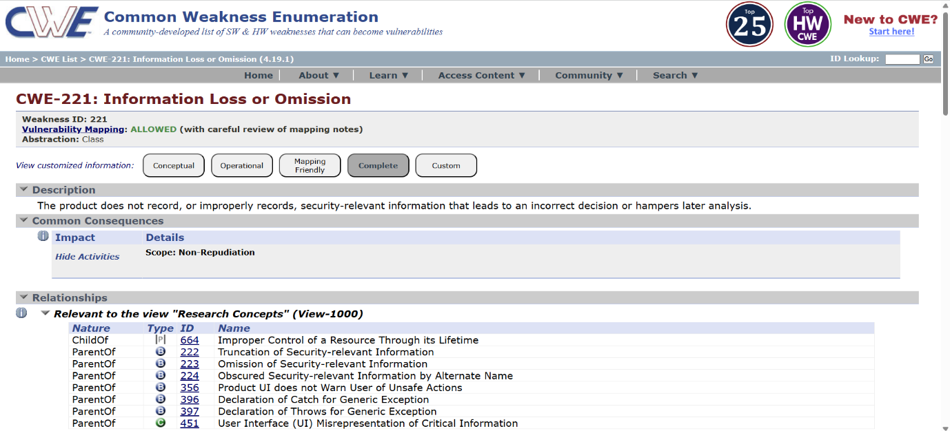
10.Vulnerability Name:
Uncaught Exception
CWE/CVE:
CWE-248 – Uncaught Exception
OWASP / SANS Category:
- OWASP Top 10: A09:2021 – Security Logging and Monitoring Failures
- SANS Top 25: Improper Handling of Exceptional Conditions
Description:
Uncaught Exception occurs when an application throws an exception or error during execution but fails to properly handle it using appropriate exception handling mechanisms. When exceptions are not caught, the application may crash, terminate unexpectedly, or expose internal system information such as stack traces, file paths, or configuration details. This can provide attackers with useful information about the system and its internal workings.
Business Impact:
If exceptions are not properly handled, the application may crash or become unavailable, resulting in service disruption and poor user experience. Additionally, unhandled exceptions may expose sensitive system information that attackers can use to identify vulnerabilities and plan further attacks. This can lead to information disclosure, reduced system availability, security risks, and potential reputational and financial damage to the organization.

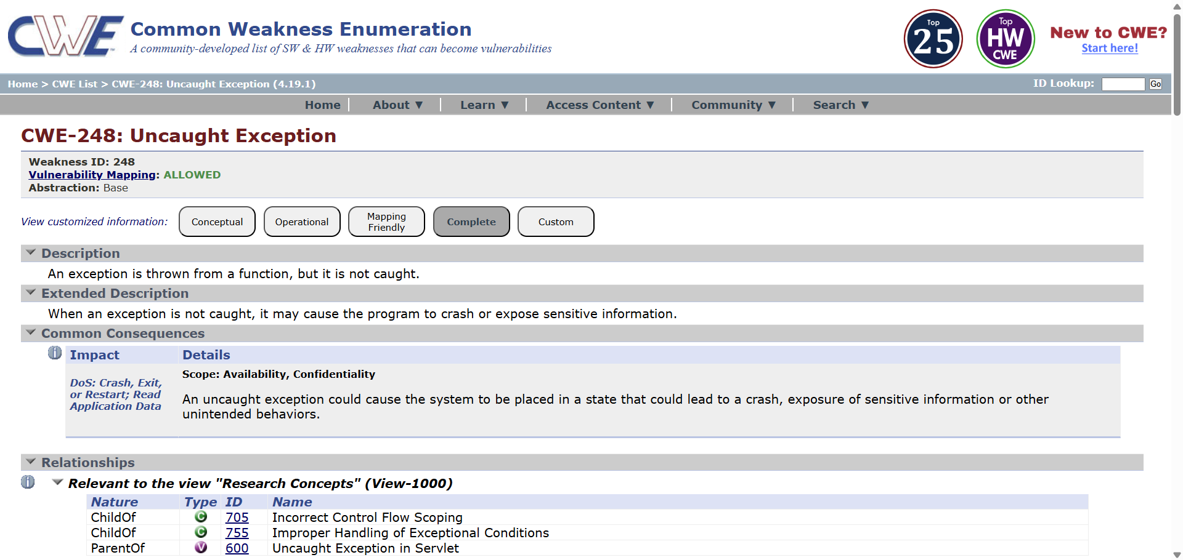
Stage 2
Overview:
Nessus is one of the most widely used vulnerability scanning tools developed by Tenable, Inc. It is designed to help security professionals identify vulnerabilities, security misconfigurations, and potential threats present in computer systems, networks, and web applications. Nessus is known as a remote vulnerability scanner, which means that it does not need to be installed on the target system. Instead, it scans the target host from another system by sending different types of probes and analyzing the responses.
The Nessus scanner works by sending various types of requests to the target host in order to discover information about the system. These probes may include network traffic requests, operating system commands, and application-level requests. Based on the responses received from the target system, Nessus identifies potential vulnerabilities and security weaknesses. This process helps security administrators detect problems such as outdated software, insecure configurations, open ports, and missing security patches.
One of the important features of Nessus is its plugin-based architecture. Plugins are small programs designed to detect specific vulnerabilities. Nessus contains a large database of plugins that are regularly updated to identify newly discovered security threats. Each plugin is responsible for checking a particular vulnerability in operating systems, applications, or network services. When a scan is performed, Nessus executes multiple plugins to analyze the target system and detect possible vulnerabilities.
During the scanning process, Nessus first performs a discovery phase, where it identifies information about the target system such as the operating system, open ports, and running services. After gathering this information, Nessus runs various vulnerability detection plugins to determine if the system contains known security weaknesses. Once the scan is completed, Nessus generates a detailed vulnerability report that includes the severity level of each vulnerability, a description of the issue, possible risks, and recommended solutions to fix the problem.
Nessus can be used to scan a wide range of targets including individual hosts, entire networks, and web applications. Security administrators can configure Nessus to scan specific IP addresses, domains, ports, or services. The scanning process can be performed manually or scheduled to run automatically at regular intervals. This flexibility makes Nessus an effective tool for continuous security monitoring.
The results produced by Nessus are categorized into different severity levels such as Critical, High, Medium, Low, and Informational, which helps security teams prioritize which vulnerabilities should be fixed first. By identifying and addressing these vulnerabilities early, organizations can reduce the risk of cyber-attacks and strengthen their overall security posture.
Overall, Nessus is a powerful and reliable vulnerability assessment tool that plays an important role in maintaining the security of modern IT environments. It helps organizations proactively detect and remediate security weaknesses before they can be exploited by attackers.
Target Website: http://zero.webappsecurity.com/
Target IP Address: 54.82.22.214
List of vulnerability:
S.No. | Vulnerability name | Severity | plugins
1 | SSL Version 2 and 3 Protocol Detection | Critical | 20007
2 | OpenSSL SSL_OP_NETSCAPE_REUSE_ CIPHER_CHANGE_BUG Session Resume Ciphersuite Downgrade Issue | Medium | 51892
3 | Apache Tomcat 7.0.0 < 7.0.82 | High | 103782
4 | SSL Weak Cipher Suites Supported | Medium | 26928
5 | SSL/TLS Diffie-Hellman Modulus <= 1024 Bits (Logjam) | Low | 83875
6 | JQuery 1.2 < 3.5.0 Multiple XSS | Medium | 136929
7 | SSL Medium Strength Cipher Suites Supported (SWEET32) | High | 42873
8 | SSL/TLS EXPORT_RSA <= 512-bit Cipher Suites Supported (FREAK) | Medium | 81606
9 | Additional DNS Hostnames | Info | 46180
10 | SSLv3 Padding Oracle on Downgraded Legacy Encryption Vulnerability (POODLE) | Low | 78479
REPORT:
01. Vulnerability Name : SSL Version 2 and 3 Protocol Detection
severity : Critical
Plugin : 20007
Port : 443 / tcp
Description :
The remote service accepts connections encrypted using SSL 2.0 and/or SSL 3.0. These versions of SSL are affected by several cryptographic flaws, including:
- An insecure padding scheme with CBC ciphers.
-Insecure session renegotiation and resumption schemes.
An attacker can exploit these flaws to conduct man-in-the-middle attacks or to decrypt communications between the affected service and clients.
Although SSL/TLS has a secure means for choosing the highest supported version of the protocol (so that these versions will be used only if the client or server support nothing better), many web browsers implement this in an unsafe way that allows an attacker to downgrade a connection (such as in POODLE). Therefore, it is recommended that these protocols be disabled entirely.
NIST has determined that SSL 3.0 is no longer acceptable for secure communications. As of the date of enforcement found in PCI DSS v3.1, any version of SSL will not meet the PCI SSC's definition of 'strong cryptography'.
Solution :
Consult the application's documentation to disable SSL 2.0 and 3.0.
Use TLS 1.2 (with approved cipher suites) or higher instead.
Business Impact :
If SSL 2.0 and SSL 3.0 protocols are enabled, attackers may exploit their cryptographic weaknesses to perform Man-in-the-Middle (MitM) attacks and intercept encrypted communications. Sensitive information such as login credentials, session cookies, and financial data could be exposed. This may result in data breaches, loss of customer trust, regulatory non-compliance (such as PCI DSS violations), financial loss, and reputational damage to the organization.
02. Vulnerability Name : OpenSSL SSL_OP_NETSCAPE_REUSE_ CIPHER_CHANGE_BUG Session Resume Ciphersuite Downgrade Issue
severity : Medium
Plugin : 51892
Port : 443 / tcp
Description :
The version of OpenSSL on the remote host has been shown to allow resuming session with a weaker cipher than was used when the session was initiated. This means that an attacker that sees (i.e., by sniffing) the start of an SSL connection can manipulate the OpenSSL session cache to cause subsequent resumptions of that session to use a weaker cipher chosen by the attacker.
Note that other SSL implementations may also be affected by this vulnerability.
Solution :
Upgrade to OpenSSL 0.9.8q / 1.0.0.c or later, or contact your vendor for a patch.
Business Impact :
This vulnerability may allow attackers to downgrade the encryption strength of SSL sessions, forcing the system to use weaker cryptographic algorithms. As a result, attackers may intercept and decrypt secure communications between clients and the server. This can lead to unauthorized access to sensitive information, compromise of secure sessions, and potential data leakage, affecting the confidentiality and integrity of business communications.
03. Vulnerability Name : Apache Tomcat 7.0.0 < 7.0.82
severity : High
Plugin : 103782
Port : 80 / tcp / www
Description :
The version of Tomcat installed on the remote host is prior to 7.0.82. It is, therefore, affected by a vulnerability as referenced in the fixed_in_apache_tomcat_7.0.82_security-7 advisory.
- When running Apache Tomcat versions 9.0.0.M1 to 9.0.0, 8.5.0 to 8.5.22, 8.0.0.RC1 to 8.0.46 and 7.0.0 to 7.0.81 with HTTP PUTs enabled (e.g. via setting the readonly initialisation parameter of the Default servlet to false) it was possible to upload a JSP file to the server via a specially crafted request. This JSP could then be requested and any code it contained would be executed by the server. (CVE-2017-12617)
Note that Nessus has not tested for this issue but has instead relied only on the application's self-reported version number.
Solution :
Upgrade to Apache Tomcat version 7.0.82 or later.
Business Impact :
If exploited, attackers may upload malicious files such as JSP web shells to the server and execute arbitrary code. This could allow attackers to gain full control of the web server, steal or manipulate sensitive data, and disrupt application services. Such compromise may lead to system takeover, operational downtime, data breaches, and significant financial and reputational losses for the organization.
04. Vulnerability Name : SSL Weak Cipher Suites Supported
severity : Medium
Plugin : 26928
Port : 443 / tcp
Description :
The remote host supports the use of SSL ciphers that offer weak encryption.
Note: This is considerably easier to exploit if the attacker is on the same physical network.
Solution :
Reconfigure the affected application, if possible, to avoid the use of weak ciphers.

Business Impact :
Supporting weak SSL cipher suites reduces the strength of encryption used in secure communications. Attackers may exploit these weak encryption algorithms to decrypt or manipulate transmitted data. This could expose confidential information such as user credentials, financial transactions, or sensitive organizational data, leading to data breaches, compliance violations, and loss of customer confidence.
05. Vulnerability Name : SSL/TLS Diffie-Hellman Modulus <= 1024 Bits (Logjam)
severity : Low
Plugin : 83875
Port : 443 / tcp
Description :
The remote host allows SSL/TLS connections with one or more Diffie-Hellman moduli less than or equal to 1024 bits. Through cryptanalysis, a third party may be able to find the shared secret in a short amount of time (depending on modulus size and attacker resources). This may allow an attacker to recover the plaintext or potentially violate the integrity of connections.
Solution :
Reconfigure the service to use a unique Diffie-Hellman moduli of 2048 bits or greater.
Business Impact :
Weak Diffie-Hellman key sizes make encrypted connections vulnerable to cryptographic attacks such as the Logjam attack. Attackers with sufficient resources may break the encryption and recover sensitive information exchanged between clients and the server. This could compromise data confidentiality, secure communications, and user privacy, potentially resulting in regulatory penalties and reputational damage.
06. Vulnerability Name : JQuery 1.2 < 3.5.0 Multiple XSS
severity : Medium
Plugin : 136929
Port : 80 / tcp / www , 8080 / tcp / www
Description :
According to the self-reported version in the script, the version of JQuery hosted on the remote web server is greater than or equal to 1.2 and prior to 3.5.0. It is, therefore, affected by multiple cross site scripting vulnerabilities.
Note, the vulnerabilities referenced in this plugin have no security impact on PAN-OS, and/or the scenarios required for successful exploitation do not exist on devices running a PAN-OS release.
Solution :
Upgrade to JQuery version 3.5.0 or later.
Business Impact :
If attackers exploit the Cross-Site Scripting (XSS) vulnerabilities in outdated jQuery libraries, they may inject malicious scripts into web pages viewed by users. These scripts can steal session cookies, redirect users to malicious websites, capture user credentials, or manipulate website content. This can lead to account compromise, data theft, and reduced trust in the organization’s web applications.
07. Vulnerability Name : SSL Medium Strength Cipher Suites Supported (SWEET32)
severity : High
Plugin : 42873
Port : 443 / tcp
Description :
The remote host supports the use of SSL ciphers that offer medium strength encryption. Nessus regards medium strength as any encryption that uses key lengths at least 64 bits and less than 112 bits, or else that uses the 3DES encryption suite.
Note that it is considerably easier to circumvent medium strength encryption if the attacker is on the same physical network.
Solution :
Reconfigure the affected application, if possible, to avoid use of medium strength ciphers.

Business Impact :
Medium-strength encryption algorithms such as 3DES are vulnerable to attacks like SWEET32, which exploit block cipher weaknesses. Attackers may capture large volumes of encrypted traffic and eventually decrypt sensitive information. This can lead to exposure of confidential communications, session hijacking, and compromise of secure transactions, potentially affecting business operations and regulatory compliance.
08. Vulnerability Name : SSL/TLS EXPORT_RSA <= 512-bit Cipher Suites Supported (FREAK)
severity : Medium
Plugin : 81606
Port : 443 / tcp
Description :
The remote host supports EXPORT_RSA cipher suites with keys less than or equal to 512 bits. An attacker can factor a 512-bit RSA modulus in a short amount of time.
A man-in-the middle attacker may be able to downgrade the session to use EXPORT_RSA cipher suites (e.g. CVE-2015-0204). Thus, it is recommended to remove support for weak cipher suites.
Solution :
Reconfigure the service to remove support for EXPORT_RSA cipher suites.
Business Impact :
The use of weak EXPORT-grade RSA encryption allows attackers to downgrade secure connections to weak encryption levels. Once downgraded, attackers may break the encryption and access sensitive information transmitted between users and the server. This could lead to unauthorized data access, credential theft, and compromise of secure communications, which may negatively impact business reputation and customer trust.

09. Vulnerability Name : Additional DNS Hostnames
severity : Info
Plugin : 46180
Port : N/A
Description :
Hostnames different from the current hostname have been collected by miscellaneous plugins. Nessus has generated a list of hostnames that point to the remote host. Note that these are only the alternate hostnames for vhosts discovered on a web server. Different web servers may be hosted on name-based virtual hosts.
Solution :
If you want to test them, re-scan using the special vhost syntax, such as : www.example.com[192.0.32.10]
Business Impact :
The discovery of additional DNS hostnames associated with the target system may reveal hidden services, alternate domains, or internal infrastructure details. Attackers can use this information during reconnaissance to identify new attack surfaces or misconfigured services. While this vulnerability is informational, it can assist attackers in planning targeted attacks against the organization’s infrastructure.
10. Vulnerability Name : SSLv3 Padding Oracle on Downgraded Legacy Encryption Vulnerability (POODLE)
severity : Low
Plugin : 78479
Port : 443 / tcp
Description :
The remote host is affected by a man-in-the-middle (MitM) information disclosure vulnerability known as POODLE. The vulnerability is due to the way SSL 3.0 handles padding bytes when decrypting messages encrypted using block ciphers in cipher block chaining (CBC) mode.
MitM attackers can decrypt a selected byte of a cipher text in as few as 256 tries if they are able to force a victim application to repeatedly send the same data over newly created SSL 3.0 connections.
As long as a client and service both support SSLv3, a connection can be 'rolled back' to SSLv3, even if TLSv1 or newer is supported by the client and service.
The TLS Fallback SCSV mechanism prevents 'version rollback' attacks without impacting legacy clients; however, it can only protect connections when the client and service support the mechanism. Sites that cannot disable SSLv3 immediately should enable this mechanism.
This is a vulnerability in the SSLv3 specification, not in any particular SSL implementation. Disabling SSLv3 is the only way to completely mitigate the vulnerability.
Solution : Disable SSLv3.
Services that must support SSLv3 should enable the TLS Fallback SCSV mechanism until SSLv3 can be disabled.
Business Impact :
The POODLE vulnerability allows attackers to exploit SSLv3 protocol weaknesses to decrypt sensitive encrypted data through a Man-in-the-Middle attack. If exploited, attackers may recover session cookies, authentication tokens, or other confidential information, leading to account hijacking and unauthorized access to applications. This could cause data breaches, regulatory violations, and damage to the organization’s reputation.

Stage 3
Security Operations Center (SOC)
A Security Operations Center (SOC) is a centralized unit responsible for monitoring, detecting, and responding to cybersecurity threats within an organization. The SOC team continuously observes network activity, analyzes system logs, and investigates suspicious events to ensure the safety of digital resources. In modern cloud environments, organizations use advanced security platforms such as Zscaler integrated with identity providers like Azure Active Directory to strengthen authentication and access control. By monitoring authentication activities and network behavior, SOC teams can quickly detect unauthorized access attempts and respond effectively to security incidents.
SOC Cycle
The SOC cycle represents the continuous process followed by security teams to maintain cybersecurity. It generally consists of several stages including monitoring, detection, investigation, response, and recovery. First, security monitoring tools collect logs and security events from different sources such as servers, applications, and authentication systems. Next, these events are analyzed to detect abnormal behavior or potential security threats. Once a threat is identified, the SOC team investigates the incident and takes necessary action to mitigate the risk. Finally, the system is restored to normal operation and improvements are made to prevent similar incidents in the future.
Security Information and Event Management (SIEM)
Security Information and Event Management (SIEM) is a technology used to collect, analyze, and manage security data from multiple systems within a network. SIEM tools gather logs from servers, firewalls, applications, and authentication systems to detect suspicious activities. In this project, SIEM solutions help monitor authentication events generated when users access applications through Zscaler and Azure Active Directory. By analyzing these logs in real time, organizations can quickly identify potential cyber threats and take appropriate action to prevent security breaches.

SIEM Cycle
The SIEM cycle involves several important stages such as log collection, data normalization, correlation, analysis, and alert generation. First, logs from different systems and network devices are collected and stored in a centralized location. These logs are then standardized to ensure consistency for analysis. Correlation rules are applied to identify patterns or suspicious activities within the collected data. If abnormal behavior is detected, the SIEM system generates alerts that notify the security team. The security analysts then investigate the alert and respond accordingly to mitigate potential threats.
Malware Information Sharing Platform (MISP)
MISP is an open-source threat intelligence platform that allows organizations to share and receive information about cyber threats. It helps security teams collect data about malware, vulnerabilities, and attack patterns from different sources. By using threat intelligence provided by MISP, organizations can identify emerging threats and strengthen their defense mechanisms. This information helps security analysts detect malicious activities earlier and improve the overall security posture of the organization.
College Network Information
The college network infrastructure consists of multiple computers, servers, and networking devices such as routers and switches connected through a local area network. Students, faculty members, and administrative staff use this network for academic activities, accessing learning resources, and managing institutional data. Since the network contains sensitive information such as student records and internal documents, it is important to implement strong security measures. Integrating secure authentication mechanisms and monitoring systems can help protect the network from cyber threats.
How SOC Can Be Deployed in the College Network
A Security Operations Center can be deployed in the college network to monitor and protect digital infrastructure. Security monitoring tools can collect logs from servers, authentication systems, and network devices. These logs can be analyzed using SIEM platforms to detect suspicious activities. By integrating Zscaler with Azure Active Directory, user authentication can be centrally managed and monitored. If any abnormal behavior is detected, the SOC team can immediately investigate the issue and take appropriate actions to prevent security incidents. This approach helps improve network security and protects sensitive institutional data.
Threat Intelligence
Threat intelligence refers to the collection and analysis of information related to potential cyber threats and vulnerabilities. Security teams use threat intelligence to understand attack patterns, identify malicious activities, and strengthen security defenses. Threat intelligence data may include information about malware, phishing attacks, malicious IP addresses, and vulnerability exploits. By analyzing this information, organizations can anticipate potential cyber threats and implement preventive measures to reduce security risks.
Incident Response
Incident response is the process of identifying, managing, and resolving cybersecurity incidents within an organization. When a security alert is generated, the incident response team investigates the issue to determine its impact and severity. The response process typically includes identifying the threat, containing the attack, removing malicious components, and restoring the system to normal operation. Effective incident response helps organizations minimize damage caused by cyberattacks and ensures quick recovery of affected systems.
QRadar and Understanding the Tool
IBM QRadar is a widely used SIEM platform that provides advanced security monitoring and threat detection capabilities. It collects security logs from various systems and analyzes them using correlation rules and analytics techniques. QRadar helps security teams detect suspicious activities and respond to threats in real time. The dashboard provides a clear view of security events, enabling analysts to investigate incidents efficiently. By using QRadar, organizations can improve their ability to detect and respond to cybersecurity threats.

Conclusion
Stage 1
Stage 1 focused on understanding the concept of integrating Zscaler with identity providers such as Azure Active Directory. It helped in learning about secure authentication methods and identifying potential security vulnerabilities in modern cloud environments.
Stage 2
Focused on understanding secure web access and network protection using Zscaler Internet Access. This stage introduced concepts such as secure web gateways, traffic inspection, and policy-based access control. It demonstrated how cloud-based security platforms help organizations protect users from malicious websites, malware, and other online threats.
Additionally, the stage covered the importance of filtering internet traffic, enforcing security policies, and monitoring user activity to maintain a secure network environment. By implementing these controls, organizations can ensure safe internet usage, prevent data leakage, and strengthen overall cybersecurity. This stage helped in understanding how modern cloud security solutions protect users and organizational resources while accessing the internet.
Stage 3
Stage 3 focused on advanced cybersecurity concepts such as SOC, SIEM, threat intelligence, and incident response. These technologies help organizations monitor network activities, detect cyber threats, and respond to security incidents effectively. Implementing these systems improves overall network security and ensures better protection of digital resources.

Future Scope
Stage 1
In the future, the integration of Zscaler with identity providers can be expanded to include additional authentication platforms and advanced security mechanisms. Automated vulnerability assessment tools can also be implemented to identify potential security risks more effectively.
Stage 2
In the future, the implementation of Zscaler Internet Access can be enhanced by integrating additional advanced web security features such as improved data loss prevention (DLP), sandboxing, and real-time threat analysis. These improvements will help organizations detect and block sophisticated cyber threats more effectively.
Furthermore, integrating cloud-based security platforms with advanced analytics and automated monitoring systems can improve visibility into network traffic and user behavior. Expanding secure web gateway capabilities and strengthening policy-based access controls will ensure safer internet usage for users working across different locations and devices. These future enhancements will further improve network security and provide stronger protection against evolving cyber threats.
Stage 3
Future improvements can include the use of Artificial Intelligence and Machine Learning technologies for advanced threat detection and automated incident response. Integrating additional security monitoring tools and expanding the SOC infrastructure will further strengthen the cybersecurity capabilities of the organization.
Topics Explored
- Cloud Security
- Identity Provider Integration
- Security Operations Center
- SIEM Monitoring
- Threat Intelligence
Tools Explored
- Zscaler
- Microsoft Azure Active Directory
- IBM QRadar
- MISP Threat Intelligence Platform

